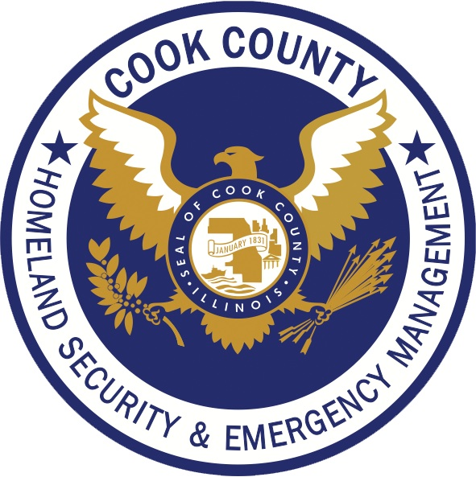

2019 Cook County
Multi-Jurisdictional Hazard Mitigation Plan Update
Public Meeting Series

Introductions
What is Mitigation?
Preliminary Questionnaire Findings
Hazard/Risk Discussion
Hazard Summary Worksheet
Identify New Mitigation Ideas/Initiatives

Take Our Survey:
http://prepare.community/cc2019

Visit our Site:
https://www.cookcountyhomelandsecurity.org

